Australia's Biodiversity Strategy

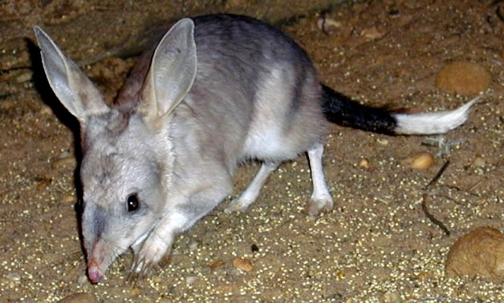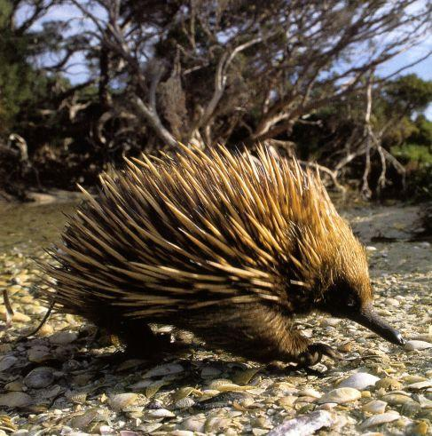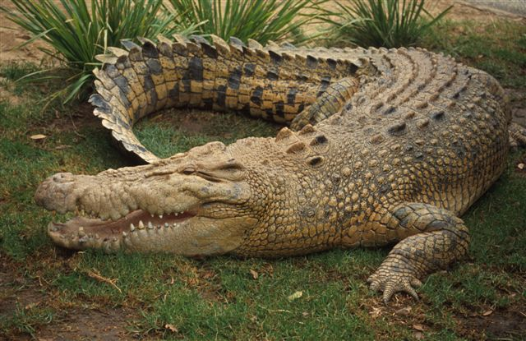

Biodiversity, or biological diversity, is the variety of all life forms. There are three levels of biodiversity:

genetic diversity—the variety of genetic information contained in individual plants, animals and micro-organisms

species diversity—the variety of species

ecosystem diversity—the variety of habitats, ecological communities and ecological processes.

Biodiversity occurs in all environments on Earth - terrestrial, aquatic and marine.

Biodiversity is not static; it is constantly changing. It can be increased by genetic change and evolutionary processes, and it can be reduced by threats which lead to population decline and extinction. Biodiversity in Australia is currently declining because of the impacts of a range of threats.

Conserving biodiversity is an essential part of safeguarding the biological life support systems on Earth. All living creatures, including humans, depend on these life support systems for the necessities of life. For example, we need oxygen to breathe, clean water to drink, fertile soil for food production and physical materials for shelter and fuel. These necessities can be described collectively as ecosystem services. They are fundamental to our physical, social, cultural and economic well-being.

Ecosystem resilience is the capacity of an ecosystem to respond to changes and disturbances, yet retain its basic functions and structures. The resilience of ecosystems in Australia is currently being reduced by a number of threats, including:

habitat loss, degradation and fragmentation, invasive species

unsustainable use and management of natural resources

changes to the aquatic environment and water flows

changing fire regimes, climate change.

For ecosystems to be resilient to these and other threats, they need a healthy diversity of individuals, species and populations.

Each of the priorities for action has measurable targets and actions which collectively provide a strategic focus for our efforts. The 10 national targets are as follows:

1.By 2015, achieve a 25% increase in the number of Australians and public and private organisations who participate in biodiversity conservation activities.

2.By 2015, achieve a 25% increase in employment and participation of Indigenous peoples in biodiversity conservation.

3.By 2015, achieve a doubling of the value of complementary markets for ecosystem services.

4.By 2015, achieve a national increase of 600,000 km2 of native habitat managed primarily for biodiversity conservation across terrestrial, aquatic and marine environments.

5.By 2015, 1,000 km2 of fragmented landscapes and aquatic systems are being restored to improve ecological connectivity.

6.By 2015, four collaborative continental-scale linkages are established and managed to improve ecological connectivity.

7.By 2015, reduce by at least 10% the impacts of invasive species on threatened species and ecological communities in terrestrial, aquatic and marine environments.

8.By 2015, nationally agreed science and knowledge priorities for biodiversity conservation are guiding research activities.

9.By 2015, all jurisdictions will review relevant legislation, policies and programs to maximise alignment with Australia's Biodiversity Conservation Strategy.

10.By 2015, establish a national long-term biodiversity monitoring and reporting system. Questions

Q1 What is biodiversity? Q2 Why do we need a biodiversity strategy?

Q3 Suggest 8 human activities that reduce Australia’s biodiversity?

Q4 What is the difference between endangered and extinct?

Q5 If you were the Premier of WA suggest 4 Laws you would make to protect WA’s biodiversity.

Q6 Name several “introduced” animals and plants that are a threat to WA’s biodiversity.

